Abstract

Step by step process for completing each level of BioRubeBot using concepts of the MAPK, cAMP, and G-Protein Signaling

Procedure for Level Completion

Daniel Hughes (Spring 2017)

David Tenneson (Summer 2017)

Casey Garcia (Summer 2017)

Revised By: Jonathan Emerson (Fall 2021)

Ryan Wood (Fall 2021)

Zacharias Steffen (Fall 2021)

Contents

Forward 2

INTRO LEVEL 1 3

INTRO LEVEL 2 4

INTRO LEVEL 3 5

LEVEL 1 6

LEVEL 2 (Draft) 9

New parts 9

Steps to Win 10

Conclusion 14

# Forward

**All items contained here within are subject to change based on the need and desires of the customer. These changes will be the result of incorrect level design, incorrect biological function, improper implementation, necessary additions to cellular function, and scientific breakthroughs. Always consult the customer for proper implementation, but also complete your own research.**

# INTRO LEVEL 1

**The player’s first introduction to the game involves dragging and dropping the receptor pair onto the cell membrane and completing phosphorylation.**

**Step 1:** Place a receptor onto the cell membrane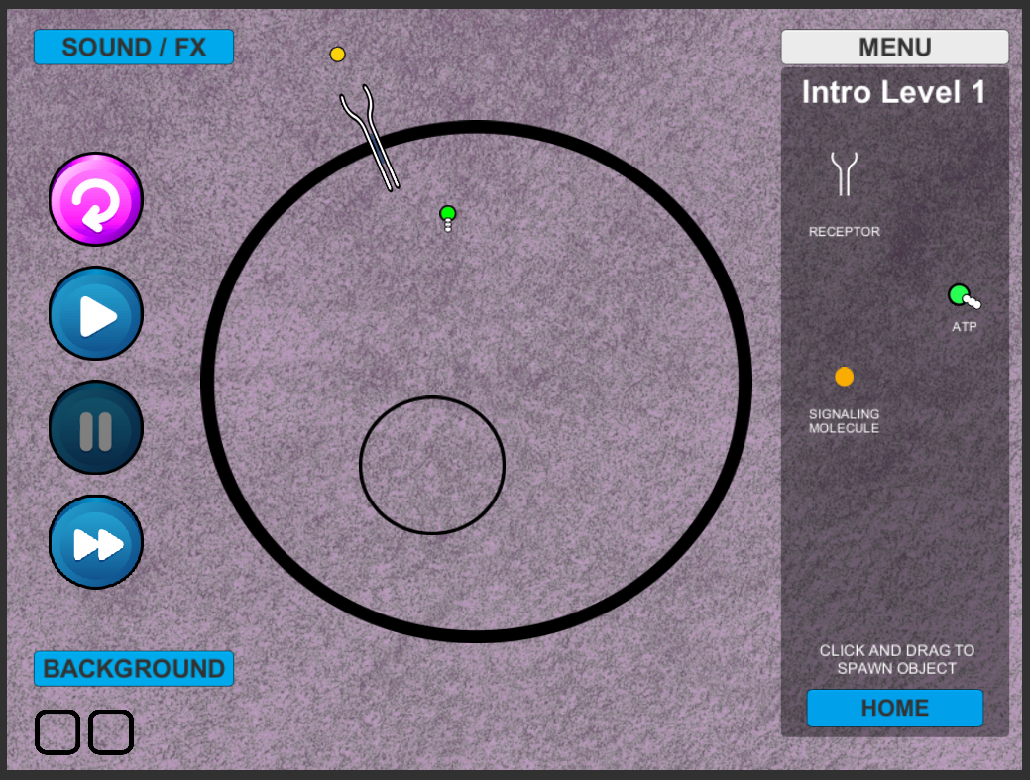

**Step 2:** Place protein signaler nearby or on the end of the receptor (this has auto tracking). This will then become activated and grey out. Notice the shape change at the end of the receptor. This will allow for the attachment of ATP.

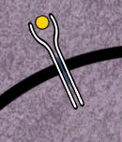 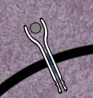

**Step 3:** Place 2 ATPs per receptor and they will track to any activated receptor and “drop” a phosphate. 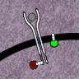

# INTRO LEVEL 2

**Following successful receptor phosphorylation, the player is introduced to several more game pieces needed to complete the next phase.**

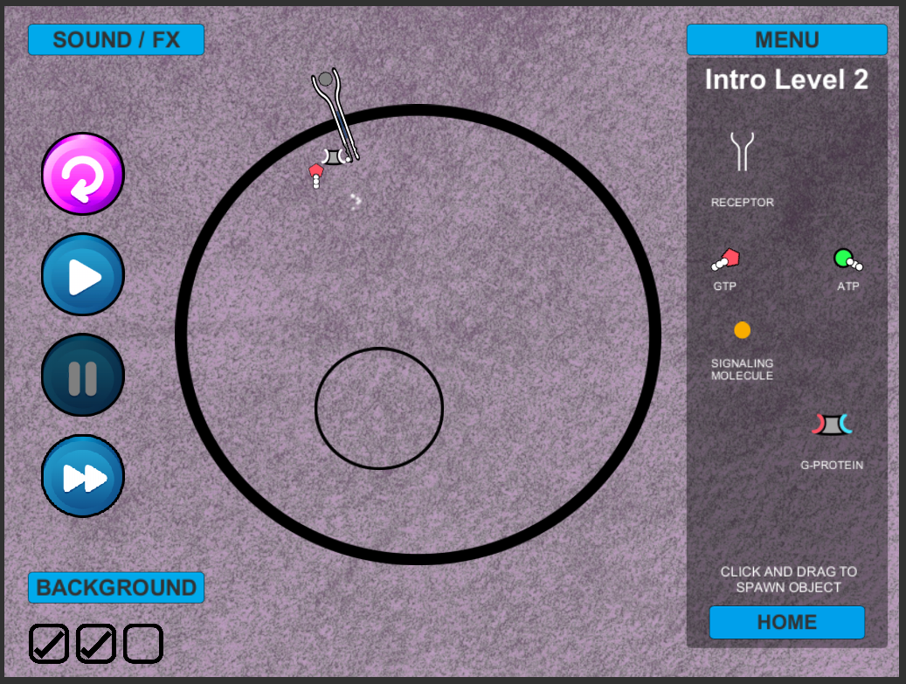

**Step 4:** Place a G-Protein into the cell, it will move toward any active receptors with phosphates. It will then activate which will cause the GDP that is attached to break off from the g-protein. It will then remain in place until it binds with a GTP. This will allow the G-protein to float free to activate the kinase.

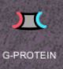🡪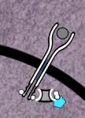 🡪 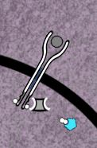🡪 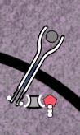🡪 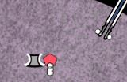

# INTRO LEVEL 3

**Once the G-Protien becomes free-floating, it then can bind to the Kinase (new). Once the Kinase has been activated, it then is ready to bind with a Transcription Regulator (new) to complete the next introductory phase.**

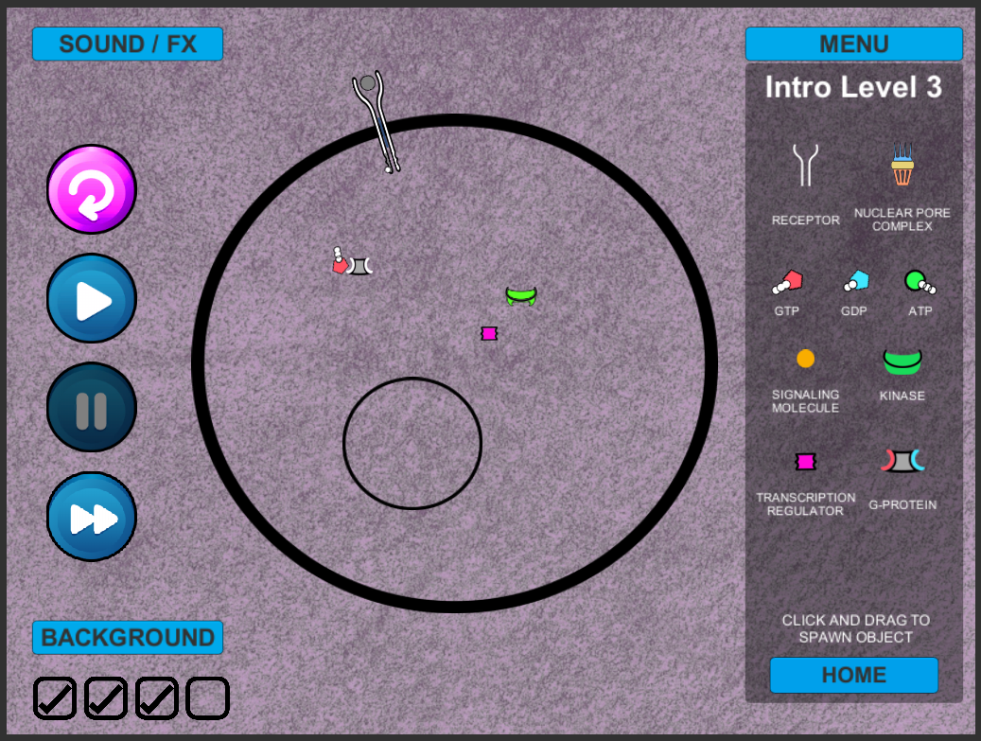

**Step 5:** Place a Kinase within the cell. It will then bind with the free-floating G-Protein. This will allow it to also bind with the transcription regulator.

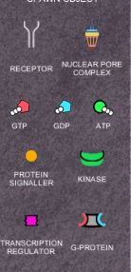🡪 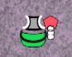 🡪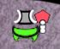🡪🡪

LEVEL 1

**Emphasizing the same general biological concepts as the first level, in Level 2 the player in shown a more accurate cell structure by having to place each half of the receptor (left and right) on the cell membrane for phosphorylation.**

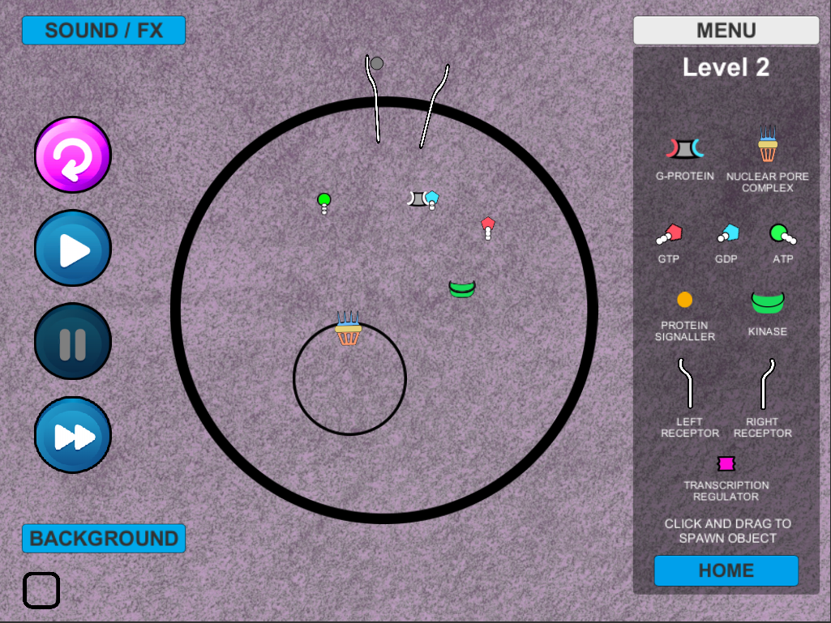

**Step 1:** User will place either a right or left receptor into the cell membrane. In this example, we will start with the left. *Note: The protein signaler will bind with the left receptor.*

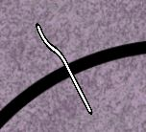

**Step 2:** The user will then place a right receptor into the cell

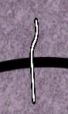

**Step 3:** Next the user will insert a protein signaler.

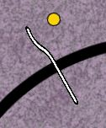

There can be two events to occur here.

1. If a right receptor is on the cell membrane enough they will move to each other to create an activated receptor.

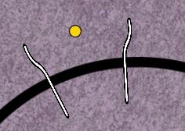🡪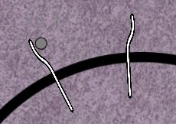🡪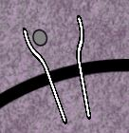🡪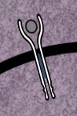

1. If a right receptor is not on the cell membrane the left the signaling protein will bind to it and no further action takes place.

🡪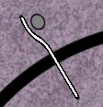

**(BUG)** if a right receptor has been placed on the nuclear membrane it will spin around indefinitely until the left binds with a right on the cell membrane.

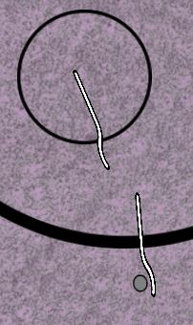🡪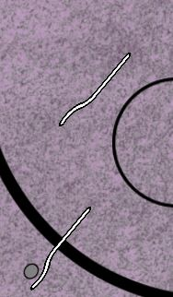

**Step 4-End:** These will follow the same procedures for winning the game as steps 3-7 in the previous level.

LEVEL 2 (Draft)

**The draft concept for Level 3, created by the Spring 2017 group in coordination with the customer, introduces the player to additional game pieces and biological functions. These pieces and functionality have not yet been implemented and would also require individual win conditions to be added. Consult with the customer before implementing any of the below features.**

New parts



GPC Receptor

**Designed and placed in prefabs.**

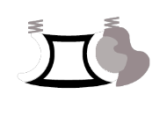🡪 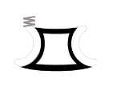🡪 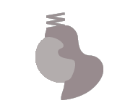

Trimeric G-Protein Alpha Subunit Beta-Gamma Complex

**Used in example and video**

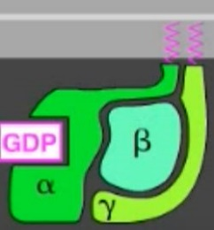 🡪 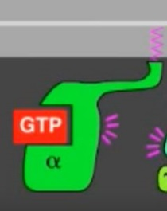🡪 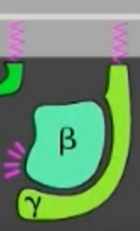

Trimeric G-Protein Alpha Subunit Beta-Gamma Complex

 🡪

Protein Kinase (PKA)

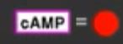

Cyclic AMP (Dr. Cline would like to differentiate this more than in the video)

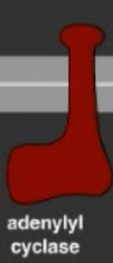

Adenylyl Cyclase

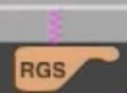

Regulatory Subunit

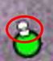

Pyrophosphate – loose phosphates (currently unsure of their role unless they just break off and float away)

Steps to Win

Step 1: G-Protein Coupled Receptor (GCR) is placed on cell membrane.



Step 2: Signaling molecule is placed outside of cell membrane and moves into receptor. The receptor will then undergo a conformational change.

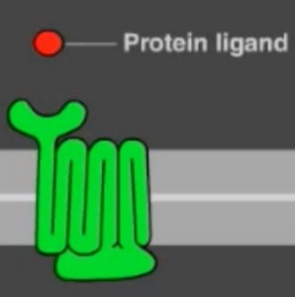🡪

*Note that activation symbols are not necessary for prefab. Note the shape difference.

* Protein ligand and signaling molecule are synonymous.

Step 3: A Trimeric G-Protein will be added to the cell membrane. It will remain attached and search for an activated GPC Receptor and bind with it.

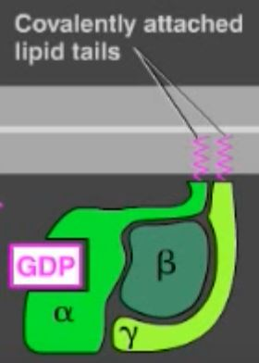 🡪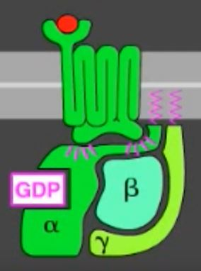

*Note Pink zigzaggy diliwaps are lipids.

Step 4: The Tri G-Protein will undergo a conformational change and lose its GDP. The user needs to place a GTP, which will find the Tri- G-Protein and bind with it.

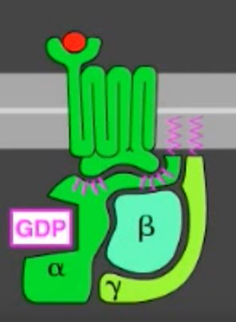 🡪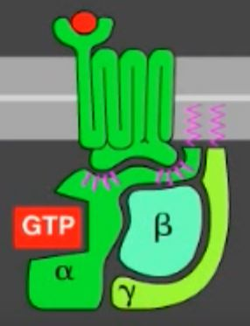

Step 5: The trimeric G-Protein will separate from the receptor and the alpha subunit and beta-gamma complex will split.

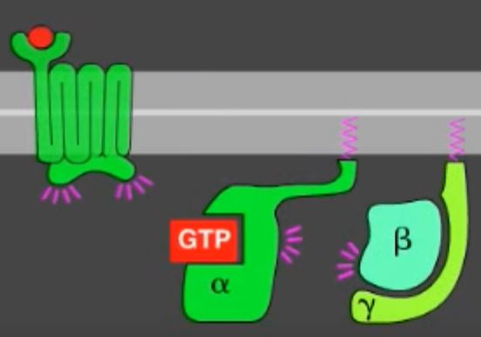

Step 6: User adds Adenylyl cyclase to the cell membrane.

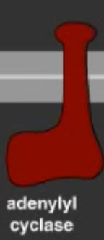

Step 7: The alpha subunit will then bind with the adenylyl cyclase and it will become activated.

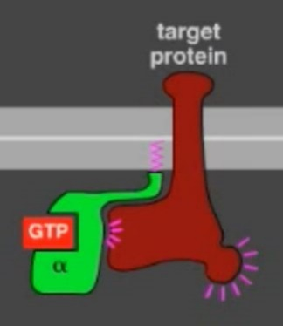

Step 8: The adenylyl cyclase will then be able to transform ATP into cAMP(cyclic AMP)

*Note cAMP should look like ATP except it will have only one dot.

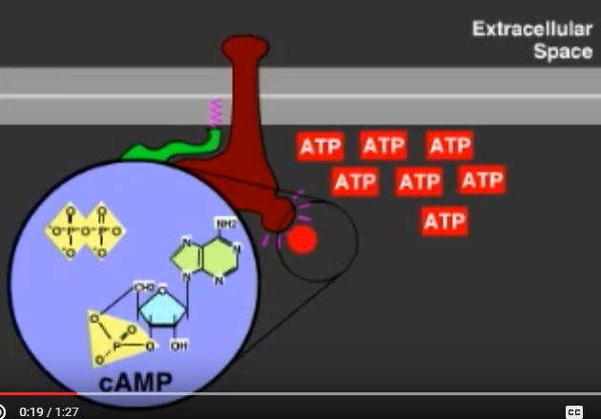🡪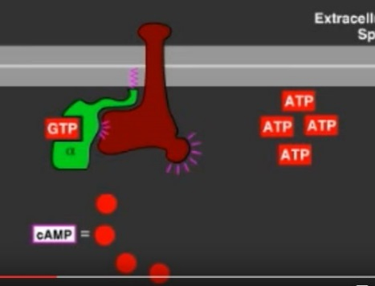

*Time the GTP to eventually turn from GTP into GDP. Timer starts after the Cyclase binding. (Roughly double the time it takes for the Kinase to activate). Once this occurs, it no longer turns ATP into cAMP. Alpha should then go back to bind with the Beta Gama.

Step 9: After the cAMP is created the GTP within the alpha subunit will hydrolyze its bound GTP and it becomes a GDP which inactivates the subunit. This is sped up by a regulator of g-protein signaling (RGS) (perhaps on a follow-on effort). The adenylyl will then become inactive.

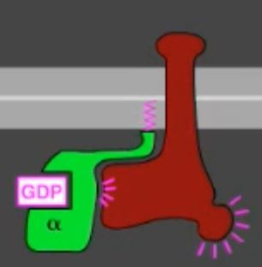🡪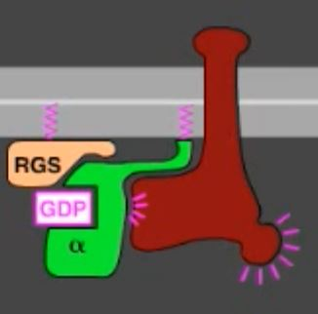🡪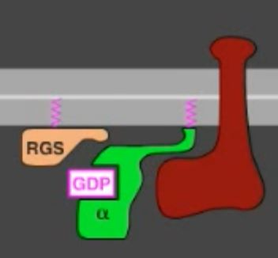

Step 10: The alpha subunit is then free to bind to a beta-gamma sub unit. (RGS is for Future dev)

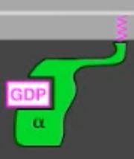🡪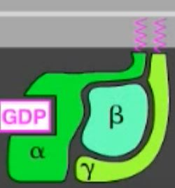

Step 9: user adds a PKA (Protein Kinase) to the cell. It will then bind with the cAMP and become activated. (one grey, one blue, simplified). We will need at least 2 cAMPs for this step.

🡪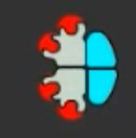🡪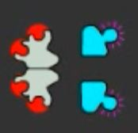🡪

Step 10: This activated subunit will enter the nucleus via the nuclear pore (which the user will need to add). It will then phosphorylate a transcription regulator (which the user will need to add). This will result in a **WIN** as the PKA moves into the nucleus. ATP will be needed to bind the transcription regulator to the PKA.

*The grey is called an inhibitory protein.

(Note: The trans. Regulator has changed function and will need to remain in the nucleus of a cell, it should no longer be able to move back through the nuclear pore)

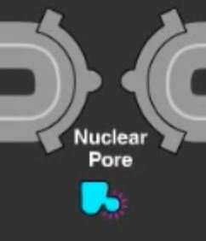🡪

Conclusion

Videos where most information can be found.

MapK signaling

<https://www.youtube.com/watch?v=r7GoZ9vFCY8&t=1s>

G-Protein signaling

[G-protein signaling - YouTube](https://www.youtube.com/watch?v=Glu_T6DQuLU)

cAMP Signaling

[cAMP signaling - YouTube](https://www.youtube.com/watch?v=hmzyHF0ECZ0)

Main Website

<http://www.onkoview.com/en/the-videos.html>

*This brief report is for reference purposes only.